What is database?

A collection of related data that is organized so that it can be easily accessed, managed, and updated.

Any collection of related information (eg: phone book)

Databases can be stored in different ways (eg: on paper, on a computer, in your mind, power point, comments section)

All organizations use data that they collect from the business. However, the data isn't very meaningful until it has been transformed into information. **Information** is organizing the data into a format that someone can analyze to create reports that can be used to make decisions.

A printed phone book or library card catalog can be considered a paper database.

DBMS (Database Management Systems)

Special software program that helps users create and maintain a database

The software that handles the storage, retrieval, and updating of the data in the computer system.

1. Makes it easy to manage large amounts of information
2. Handles Security
3. Backups
4. Importing/exporting data
5. Concurrency
6. Interacts with software applications

* Programming languages

DBMS is the software application used to create, read, update and deleting the information from the database.

C-Create

R-Read

U-Update  
D-Delete

Two types of Databases:

1. Relational Databases:

The relational database model was first introduced in 1969-1970.

A database where the data is stored in a table format with rows and columns. Each table is related to another table through a primary key.

Organize data into one or more tables

* Each table has columns and rows
* A unique key identifies each row
* (like an excel sheet that has rows and columns)

Data Integrity: The assurance of the accuracy and consistency of the data.

Data Redundancy: Data that is duplicated in the database. This should be minimized by the design of the tables.

Foreign Key (FK): The FOREIGN KEY is a key that is used to connect two tables. The FOREIGN KEY is a column or columns in one table that refers to the PRIMARY KEY column in another table.

Primary Key (PK): The primary key is a column or columns that uniquely identifies each row in the table. It cannot be left blank.

Record: A row in a database table. It is a collection of data fields about one item.

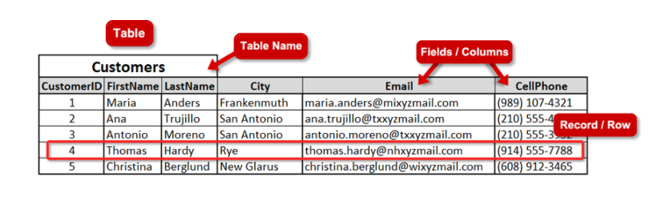

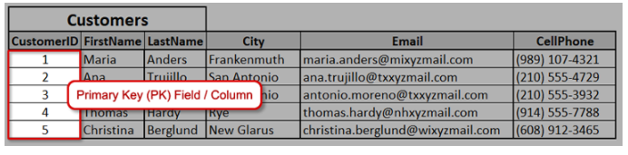

A PK field is unique for each record to identify the record.

A PK field cannot be left blank.

The PK must be entered when the record is created.

The PK cannot be changed.

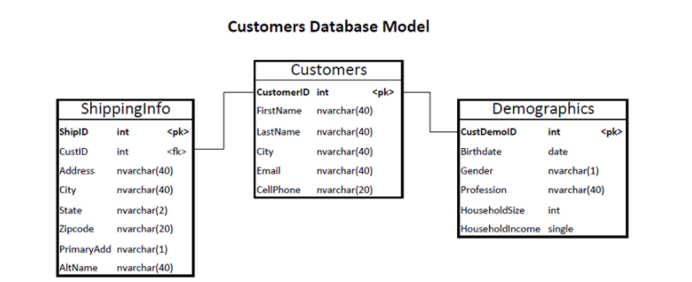

To create a relationship with the FKs and PKs:

The FK must be the same data type as the PK.

Some RDBMS platforms are:

MySQL

Microsoft SQL Server

Oracle

IBM Db2

PostgreSQL

SQLite

1. Non-Relational Databases(noSQL)--General category that is not relational

Organize data is anything but a traditional table

* Key-value pairs
* Documents (JSON, XML, etc)
* Graphs
* Flexible Tables

RDMS(Relational Database management Systems)

* Help users create and maintain a relational database (eg: mySQL, Oracle, postgreSQL, mariaDB)

Structured Query languages--used to interact with relational databases

* Used to perform CRUD operations as well as other administrative tasks (user management, security, backup)
  + Used to define tables and structures
  + SQL code used on one RDBMS is not always portable to another without modification

Non-relational Database management Systems(NRDBMS)

* Helps users create and maintain a non-relational database
  + mongoDB, dynamoDB, apache cassandra, firebase, etc

Implementation-specific

* Any non-relational database falls under this category, so there is no set language standard
* Most NRDBMS will implement their own language for performing CRUD and administrative operations on the database

Database Queries:

* Queries are requests made to the database management system for specific information
* As the database’s structure become more and more complex it becomes more difficult to get the specific pieces of information we want
* A google search is query
* 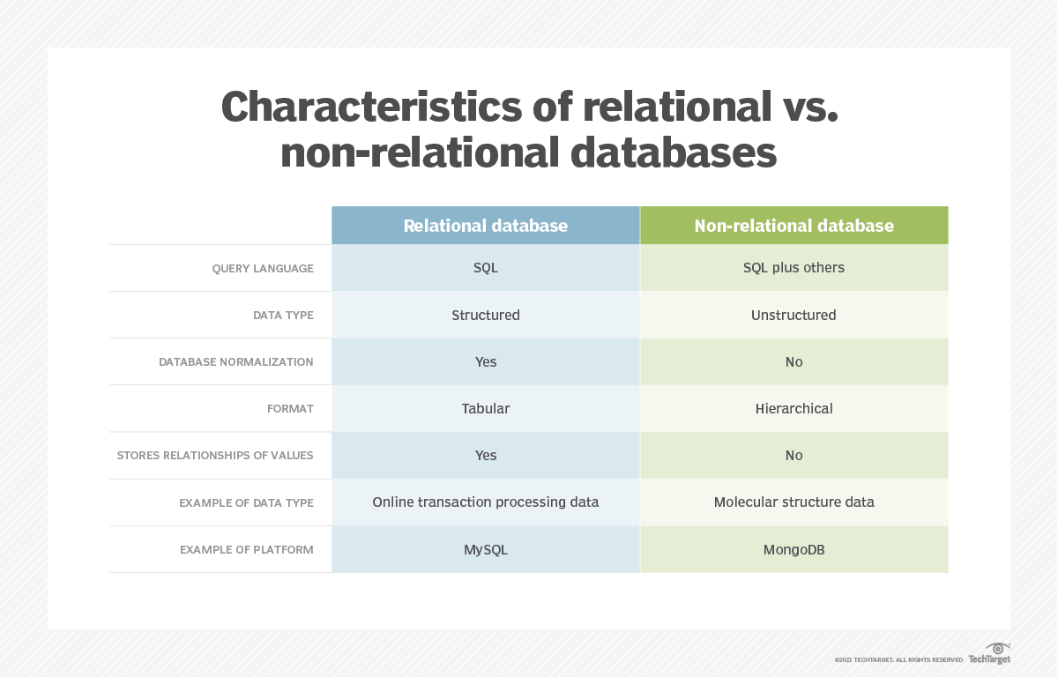

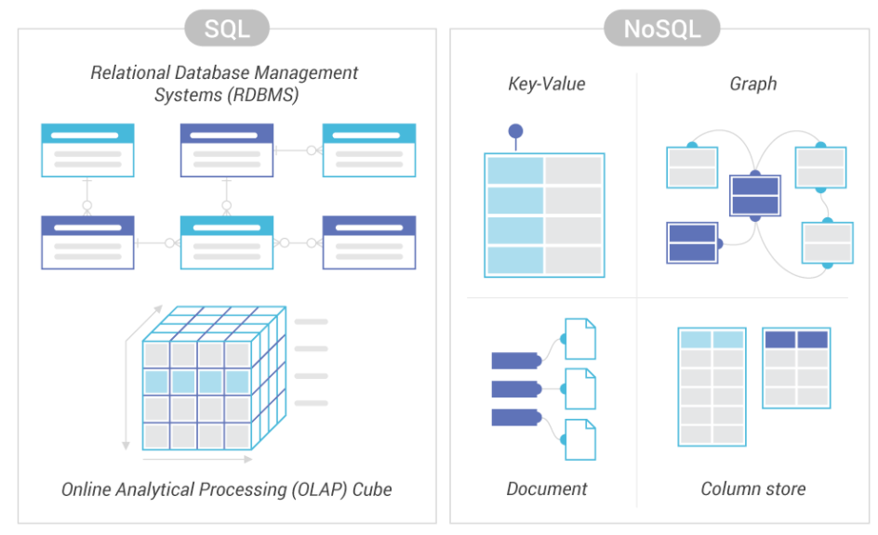

Example of a relational Database (columns and rows):

Primary key: attribute that uniquely defines the row in a database

Primary key Primary Key

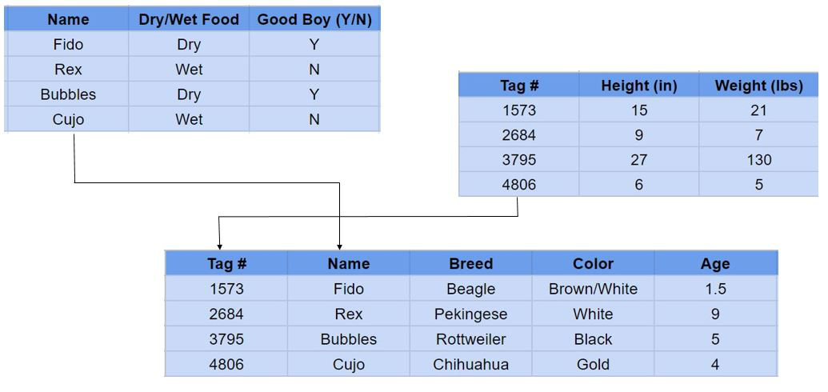

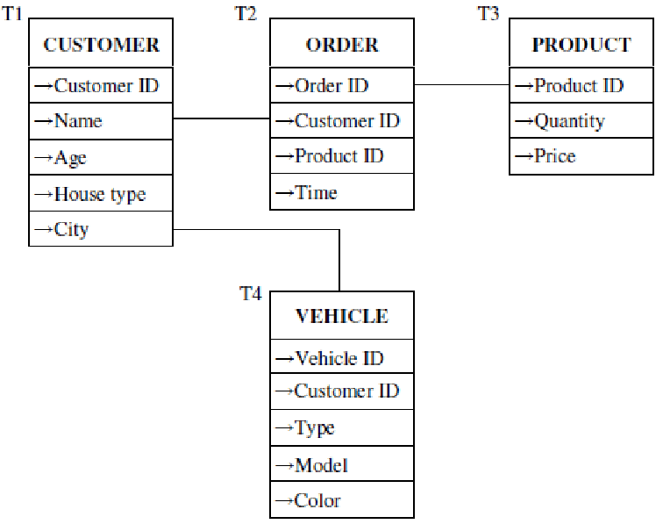

Serrogate key:type of primary key that has no mapping to the real world

Natural key: has a mapping to the real world

Foreign key:attribute that we can store on a database table that can link us to another database table, store the primary key of a row in an another database table

Relationships between two tables

A table can have more than one foreign key

Composite key: have 2 attributes

Example of non relational database:

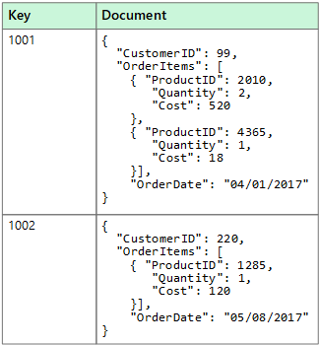

SQL:

SQL(Standard Query Language) used in managing data in relational databases

SQL is a programming language when working with organizational database to manage, maintain, manipulate and secure the data

SQL implementations vary between systems

* Not all RDBMS follow the SQL standard
* The concepts are the same but the implementation may vary

It is a hybrid language

Data query language (DQL)

* Used to query the database for information
* Get information that is already stored there

Data definition language (DDL)

* Used for defining database schemas
* CREATE: to create an object
* DROP: deletes an object
* ALTER: modifies the structure of an existing object

Data control language(DCL)

* Used for controlling access to the data in the database
* User and permissions management

Data Manipulation language(DML)

* Used for inserting, retrieving updating and deleting data from the database

Queries:

A query is set of instructions given to the RDBMS (written in SQL) that tell the RDBMS what information you want it to retrieve for you

Eg: SELECT * FROM TABLE;

**If we want to limit to number of columns then**

SELECT FirstName, Email

FROM Customers

The keywords (SELECT, FROM, WHERE) can be written upper-case, lower-case or mixed-case

Using a ; (semicolon) at the end of a SQL statement is required in some database platforms.

**If you want to retrieve only some of the data rows, you will filter the rows (filter rows) using a WHERE clause.**

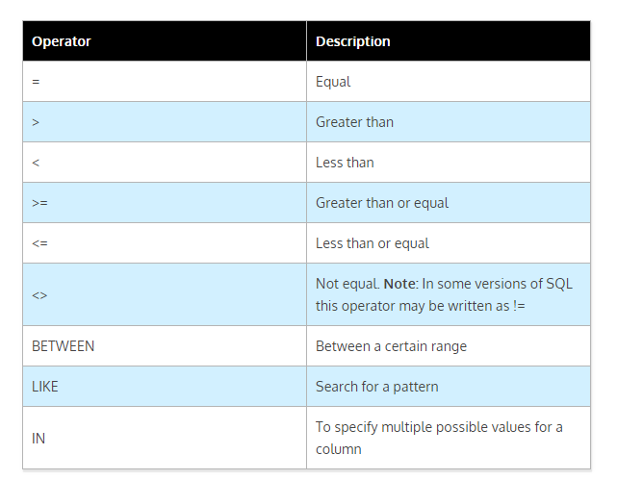

SELECT FirstName, LastName, CellPhone

FROM Customers

WHERE City = 'San Antonio'

Text values will always be enclosed in ' ' (single quotes).

Number values will be written as a number without quotes.

You can type the columns in any order when you write the query statement.

When you have two criteria, you combine two conditions. Using AND means that both of the conditions have to be true. Using an OR means that only one of the conditions has to be true.

SELECT FirstName, LastName, CellPhone

FROM Customers

WHERE City = 'San Antonio' AND City = ‘Dalton’

**Sorting Data**

The process of organizing data in a particular order allowing for information to be found more easily. For example, sorting names in alphabetical order.

ORDER BY: SQL clause used to sort the result-set in either ascending or descending order.

DESC: SQL keyword used with the ORDER BY clause to indicate descending order. For example, 5, 4, 3, 2, 1 or E, D, C, B, A.

ASC: SQL keyword used with the ORDER BY clause to indicate ascending order. For example, 1, 2, 3, 4, 5 or A, B, C, D, E.

SELECT FirstName, LastName, City

FROM Customers

ORDER BY City

By default, the ORDER BY clause will sort the result-set in ascending order. To retrieve a result-set in a descending order, the DESC keyword must be specified. It is good practice to specify ASC in the ORDER BY clause query statement for clarity.

SELECT FirstName, LastName, City

FROM Customers

ORDER BY City DESC

SELECT FirstName, LastName, City

FROM Customers

ORDER BY City, LastName

You can have several columns in your sort list in the ORDER BY clause. However, the columns should only be listed if they are necessary. Adding more columns to the list could slow the processing speed of the database in a large result-set.

MySQL installation:

Below is the link for MySQL installation on windows:

<https://www.sqlshack.com/how-to-install-mysql-database-server-8-0-19-on-windows-10/>

Best Editors used for MySQL:

<https://codingsight.com/10-best-mysql-gui-tools/>

CREATE TABLE: CREATE TABLE is a SQL statement that is used to create a new table in a database.

ALTER TABLE: ALTER TABLE is the SQL statement that is used to alter or change the structure of an existing database table. This statement can be used to add constraints.

Constraint: A SQL constraint is a rule for data in the database.

PRIMARY KEY (PK): A PRIMARY KEY is a SQL constraint. It is the column that uniquely identifies each row in the table. A PK cannot be NULL, and there can only be one PK in each table.

FOREIGN KEY (FK): A FOREIGN KEY is a key used to relate or link two tables together. The PK is a column in one table that refers to the FK in another table.

Data Types: The data type of a column defines what value the column can store.

nvarchar: A data type that can hold string data. Also, a variable width that also holds unicode data or multilingual data.

int: A data type that holds whole numbers.

decimal (p, s): A data type that holds numbers with decimals. The default size is 18 numbers (precision) and 0 decimals (scale).

date: A data type that stores dates only.

NULL: A constraint that indicates the data can hold null values or that the column can be empty of data.

NOT NULL: NOT NULL is a constraint rule that ensures there is always data entered in a column. A new row cannot be added without data in the column that is defined as NOT NULL.

DROP TABLE: DROP TABLE is a SQL statement to remove a table and all its data rows from the database.

Debugging: Making corrections to remove bugs or errors in the code.

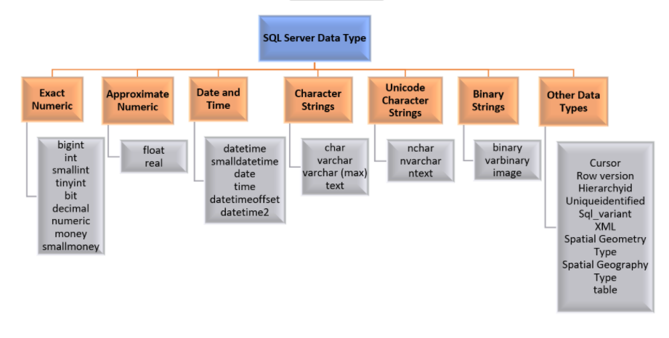

**Creating a table in the database**

CREATE TABLE tablename ( opening parenthesis

Column_name data type(parameters) constraint,

Column_name data type(parameters) constraint,

Column_name data type(parameters) constraint,

Column_name data type(parameters) constraint,

Column_name data type(parameters) constraint,

Etc…

*CONSTRAINT PK_column_name PRIMARY KEY (column_name)

) closing parenthesis

*The primary constraint does not have to be included in the table definition. It can be defined later with the ALTER TABLE command. It is important that a PK be defined before adding data for the integrity of the database.

Constraints are used to ensure that the integrity of the data is maintained.

With a unique PK for each row, repetitive or duplicated data should be minimized.

CREATE TABLE Demographics (

CustDemoID int,

Birthdate date,

Gender nvarchar(1),

Profession nvarchar(40),

HouseholdSize int,

HouseholdIncome decimal(10,2),

CONSTRAINT PK_Demographics PRIMARY KEY (CustDemoID)

)

**Drop the table**

DROP TABLE tablename

**Alter the table**

ALTER TABLE Demographics

ADD CustID int

When you add a column to the table structure that will be used to create the link between two tables, the column definition must be the same as the column it will reference—the same data type and the same length.

INSERT INTO… VALUES: A SQL statement used to insert data rows in a database table.

Column list: The list of columns that are in the table structure. These are the table columns that will be added in the INSERT INTO SQL statement.

Value list: The data values that will be added to the table columns in the INSERT INTO SQL statement.

Duplicate key: A key value that is being added to the database table that violates the PRIMARY KEY constraint.

INSERT INTO tablename

(column1, column2, column3, …)

VALUES

(value1, value2, value3, …)

The first part is the INSERT INTO tablename that tells the database which table is having data rows added.

The next section is the list of columns that will have data added. This column list is important to understand before you write your query and execute it to add the data.

The column list does not have to be in any order.

You need to know the columns that are required (NOT NULL).

Columns that are required must be included in the list unless they are automatically populated with a default value or an IDENTITY value (such as an automatic ID number).

Columns that are defined as NULL or have no constraint can be left out of the column list. However, the database will leave that value NULL or blank in the data row.

You need to know the maximum length of data that can be added or stored.

You need to know the date format if there is a date column.

You need to know any other required constraint.

Next is the VALUES keyword and then the value list. This value list is very important.

The values must follow in the same order as the column list. Value1 must match column1.

The value list must be the correct data type.

The value list must be the correct length, format, and meet any other required constraint or condition.

You need a value for every column in the column list.

String, dates, and character data are enclosed in ′ ′ (single quotes).

Numeric data does not need quotes.

CREATE TABLE Demographics (

CustDemoID int,

Birthdate date,

Gender nvarchar(1),

Profession nvarchar(40),

HouseholdSize int,

HouseholdIncome decimal(10, 2),

CONSTRAINT PK_Demographics PRIMARY KEY (CustDemoID)

)

The PK definition for CustDemoID means it is considered NOT NULL or it is required.

All the other columns are not required or can be left NULL.

The nvarchar data type values must have single quotes.

The date data type value must have single quotes and must be in the correct format for SQL Server 'YYYY-MM-DD.'

The integer data type value cannot have decimals.

For the decimal data type value, if the data entered does not have a specified decimal value, it will result in ###.00 for the value

INSERT INTO Demographics

(CustDemoID, Birthdate, Gender,

Profession, HouseholdSize, HouseholdIncome)

VALUES

(2, '1991-05-24', 'F',

'Firefighter', 4, 50698)